Practical Bioinformatics for Biologists – personal project

This text file takes you trough the work approach of my personal project in the Practical Bioinformatics for Biologists course.

Approach:

- The data files in this project were obtained in a study on the response of Drosophila larvae after parasitizing. The RNA of the larvae was isolated and transferred to cDNA. Next Generation Sequencing was performed to assess the level of gene transcription (gene expression). The read depth per gene reflects the level of expression.
- I received several FASTQ files, 2 per sample.
- I started with taking a look at the data with the command: less
- The file looks like this:
sudo ln -s /path/to/FastQC/fastqc /usr/local/bin/fastqc

@HWI-ST0310R:359:C0TGDACXX:3:1101:2832:2200 1:N:0:GCCAAT
GGTGTGGAAGCGAAGGAAGTCGGCCAACTTGGCACGGTTGTTGCTGTCCTCGTGCACACCCAGCTTCAGGTTCTTGCTGAACTGGTCATAGAACTTCTT
+
CCBFFFFFHHGHHIJJJJJGHJJIIJJJJJJJJIIJJFHIIJJJJIJJJJHHHHFFFFEDDDDDDDDDDDACDDDDDDCCDDDC?>CCDACDDDDDDDD

Every sequence and its information consists of 4 lines. The header starts with an ‘@’, followed by a line with the RNA sequence. The third line is a ‘+’. And the final line is a base-quality line phred scaled probability that the base is wrong.

- Since every header starts with an ‘@’ my initial idea to count the number of sequences was to use the command grep -c "@". However, some of the the 4th lines also contain an ‘@’, therefor that particular command does not work in this case. I cot the following output:
p268859@fwn-biol-144-40:~/PCfB2018$ grep -c "@" Dm_58_GCCAAT_L003_R1_001.fastq
19101121

The correct way to count the number of sequences in this case would be to count the number of lines and divide this by 4 (as every sequence and its information consists of 4 lines).

I used the following command:

cat Dm_58_GCCAAT_L003_R1_001.fastq | echo $((`wc -l`/4))
And got output: 11135518
Because I have over 11 million sequences I decided to create a new file with only a few sequences where I could test my commands. I did this with the following command:

head -15 Dm_58_GCCAAT_L003_R1_001.fastq > Reads.fastq
This command copied the first 50 lines of the file ‘ Dm_58_GCCAAT_L003_R1_001.fastq’ to the new file ‘Reads.fastq’
I wanted to find out what kind of file I am working with (Illumna or Sanger), and looked at the base quality scores.

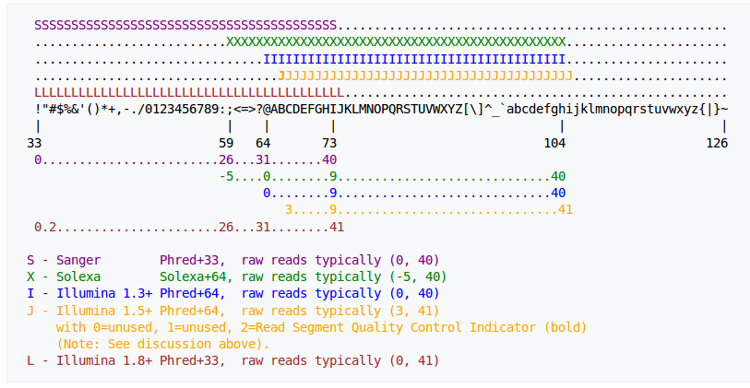
The table (https://en.wikipedia.org/wiki/FASTQ_format) shows which type of quality schemes can be used (Sanger, Solexa or Illumina). When I look at my file I can easily spot a few often used characters in the quality line, such as: CFHJG@<#F2!? This tells me that I am either dealing with Sanger or Illumna Phred 33. The difference between Sanger and Illumna is that Illumna contains one more character than Sanger, which is the character ‘J’
I searched to see if my file contains any ‘J’ characters in the base quality line with the following command:
grep "J" Dm_58_GCCAAT_L003_R1_001.fastq

this gave a lot of output (which I actually had to kill with Ctrl +c), which tells me that I am dealing with an Illumna 33+ file.

I want to check the quality of my sequence data. The tool to check this is FASTQC (https://www.bioinformatics.babraham.ac.uk). This tool provides a modular set of analyses which can be used to give a quick impression of whether the data has any problems of which you should be aware before doing any further analysis. You can also run FastQC in the shell/terminal.
I installed fastqc in with the following commands:
wget http://www.bioinformatics.babraham.ac.uk/projects/fastqc/fastqc_v0.11.5.zip
unzip
cd FastQC
chmod 755 fastqc
sudo ln -s /home/laura/FastQC/fastqc /usr/local/bin/fastqc
Now fastqc is installed and can be started from every working directory. Not the program is installed I will analyze one of the fastq files with fastqc, with the following command:

fastqc Dm_58_GCCAAT_L003_R1_001.fastq
To run all fastq files in a directory I could have used the command:

fastqc *.fastq

Running fastqc leads to a compressed fastqc file with information on the sequence file and an html file, the files are placed in the same folder as where the original fastq files are placed.
The HTML file is visual output on some basic quality scores.
The zipped files can be unzipped with the following command:
unzip \*.zip
This leads to a new directory with the file with several files containing information on the analysis of the quality of the RNA sequence.
I am interested in the files: summary.txt and fastqc_data.txt
The summary file looks like this:
PASS Basic Statistics Dm_58_GCCAAT_L003_R1_001.fastq
PASS Per base sequence quality Dm_58_GCCAAT_L003_R1_001.fastq
WARN Per tile sequence quality Dm_58_GCCAAT_L003_R1_001.fastq
PASS Per sequence quality scores Dm_58_GCCAAT_L003_R1_001.fastq
FAIL Per base sequence content Dm_58_GCCAAT_L003_R1_001.fastq
FAIL Per sequence GC content Dm_58_GCCAAT_L003_R1_001.fastq
PASS Per base N content Dm_58_GCCAAT_L003_R1_001.fastq
PASS Sequence Length Distribution Dm_58_GCCAAT_L003_R1_001.fastq
FAIL Sequence Duplication Levels Dm_58_GCCAAT_L003_R1_001.fastq
WARN Overrepresented sequences Dm_58_GCCAAT_L003_R1_001.fastq
PASS Adapter Content Dm_58_GCCAAT_L003_R1_001.fastq
FAIL Kmer Content Dm_58_GCCAAT_L003_R1_001.fastq

I want to create a table that immediately shows me per sequence file whether or not the they passed the criteria in this file.To do this I have to copy the columns form several files and past them together in on new textfile.
I will do this by fist copying all summary files (from different sequences) in one new output file. Note that these summary files are all located in different directories. So I will use the following command:
paste */sum*.txt > allsummaries.txt
Then, I will extract all columns stating “pass, warn, fail, etc, and paste this into a new text file called passandfail with the following command:
cut -f 1,4,7,10,13,16,19,22,25,28,31,34,37,40,43,46,49,51,54 allsummaries.txt> passandfail.txt
Note that this only works for a maximum of 19 different summary files, I you want to extra the column from more than 19 files you should add extra columns to the list adding 3 (57, 60 etc).
Now we have a document like this:
PASS PASS
PASS PASS
WARN WARN
PASS PASS
FAIL FAIL
FAIL FAIL
PASS PASS
PASS PASS
FAIL FAIL
WARN WARN
PASS PASS
FAIL FAIL

So we need a new column describing what was passed and what was failed, we do this by extracting the column to a new file and pasting this file together with the pass and fail file with the following two commands:
cut -f 2 allsummaries.txt >> Column1.txt
paste Column1.txt passandfail.txt > table.txt

Now we have the following file:
Basic Statistics PASS PASS
Per base sequence quality PASS PASS
Per tile sequence quality WARN WARN
Per sequence quality scores PASS PASS
Per base sequence content FAIL FAIL
Per sequence GC content FAIL FAIL
Per base N content PASS PASS
Sequence Length Distribution PASS PASS
Sequence Duplication Levels FAIL FAIL
Overrepresented sequences WARN WARN
Adapter Content PASS PASS
Kmer Content FAIL FAIL

Now we need a header describing which pass/fail column belongs to which fastq file.

We can do this by extracting the 3rd/6th/9th etc word from the allsummaries.txt file and create a header.

head -1 allsummaries.txt | cut -f 1,3,6,9,12,15,18,21,24,27,30,33,36,39,42,45,48,51,54,57 > header.txt

Note: again this only works for a maximum of 19 fastq files.
This also copies the first word of the file, we need this because otherwise the header will not align the table properly, we will remove this later. Now we past the header and the table together, with the following command:

cat header.txt table.txt > newtable.txt

This created the following table:
PASS Dm_58_GCCAAT_L003_R1_001.fastq Dm_58_GCCAAT_L003_R1_001.fastq
Basic Statistics PASS PASS
Per base sequence quality PASS PASS
Per tile sequence quality WARN WARN
Per sequence quality scores PASS PASS
Per base sequence content FAIL FAIL
Per sequence GC content FAIL FAIL
Per base N content PASS PASS
Sequence Length Distribution PASS PASS
Sequence Duplication Levels FAIL FAIL
Overrepresented sequences WARN WARN
Adapter Content PASS PASS
Kmer Content FAIL FAIL

The word PASS can be replaced manually (and replaced by for example the name of the table) if wanted or needed.

Now I will summarize all used commands in a shell script.
Shell script:
__________________________________________________________________
#!/bin/bash
#This is a script that will analyze fastq files with the program fastqc and makes a table called "newtable.txt" with a summary of the results
#To execute this program fastqc needs to be installed
#This program should be executed while you are in the directory containing the fastq files
fastqc *.fastq #all fastq files in the directory are analyzed with fastQC
unzip \*.zip #the output files of fastqc are unzipped
paste */sum*.txt > allsummaries.txt #this copies the summaries of every analysis into one new file.
cut -f 1,4,7,10,13,16,19,22,25,28,31,34,37,40,43,46,49,51,54 allsummaries.txt> passandfail.txt #this cuts the columns stating whether the sequence has passed or failed certain criteria
cut -f 2 allsummaries.txt >> Column1.txt #this cuts the criteria which can be passed or failed to a new file
paste Column1.txt passandfail.txt > table.txt #this combines the criteria and pass and fail columns.
head -1 allsummaries.txt | cut -f 1,3,6,9,12,15,18,21,24,27,30,33,36,39,42,45,48,51,54,57 > header.txt #this creates the header
cat header.txt table.txt > newtable.txt #this combines the header and the table into one new file.
__________________________________________________________________

This file was saved as fastqcsummary.sh and made executable, I ran the script and it led to the expected output.

